CHIKKANNA GOVERNMENT ARTS COLLEGE
TIRUPUR-641602
(AFFILIATED TO BHARATHIAR UNIVERSITY)

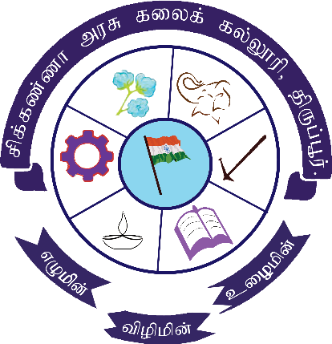

TEAM MEMBERS NAME :
PAVITHRA P (2022K0011)
NANDHINI A (2022K0008)
NIVEDHITHA A (2022K0009)
BHARATHI S (2022K0002)
INDHUMADHI S (2022K0005)

DEPARTMENT OF COMPUTER SCIENCE

CHIKKANNA GOVERNMENT
ARTSCOLLEGE

NAAN MUDHALVAN PROJECT WORK
(AFFILIATED TO BHARATHIAR UNIVERSITY)
TIRUPUR-641602
TITLE :Early Prediction For Chronic Kidney Disease Detection:a Progressive Approach To Health Management
This is to certify that this is a bonafide record of work done by the above students of III B.Sc (CS) Degree NAAN MUDHALVAN PROJECT during the year ……….
Submitted for the Naan Mudhalvan project work held
on………….20
CLASS TUTOR HEAD OF THE DEPARTMENT

INDEX

S.No. | Date | Contents | Page No.
1 |  | PROBLEM SELECTION | 1
2 |  | IDEATION | 2
3 |  | REQUIREMENT ANALYSIS | 3
4 |  | PROJECT DESIGN | 4
5 |  | PROJECT PALNNING PHASE | 5
6 |  | PROJECT DEVELOPMENT PHASE | 6
7 |  | RESULT(INPUT & OUTPUT) | 7

PROBLEM SELECTION
1. The selection of the "Early Prediction Chronic Kidney Disease Detection: A Progressive Approach to Health Management" project requires
2. Firstly, the project should align with the organization's overall strategy and mission. If the organization's mission is to improve health outcomes for patients with chronic conditions, then this project would be a suitable choice.
3. Secondly, the project should address a significant problem or challenge faced by the organization. Chronic kidney disease is a prevalent condition that can lead to severe health complications if not managed appropriately. This project aims to address this problem by developing a machine learning model and web application to predict CKD likelihood and improve health management for patients.
4. Thirdly, the project should have clear goals and objectives. The project's objectives should be specific, measurable, achievable, relevant, and time-bound (SMART). The goals of this project are to develop a machine learning model and web application that accurately predict CKD likelihood and improve health management for patients.
5. Lastly, the project should have a clear plan for implementation, including project milestones, timelines, and risk management strategies. The project manager should develop a project plan that outlines the project's scope, goals, and objectives, and sets realistic timelines for each project phase.

IDEATION
- Chronic kidney disease (CKD) is a condition that affects millions of people worldwide and can lead to serious complications such as kidney failure if left untreated. Early detection of CKD is crucial for effective management and prevention of further damage to the kidneys.
- One potential solution for early detection of CKD is the use of predictive analytics and machine learning algorithms. By analyzing a patient's medical history, demographics, and other relevant data, these algorithms can identify individuals who are at high risk of developing CKD. This information can then be used to initiate early interventions and lifestyle modifications that can help slow the progression of the disease.
- Once a patient has been diagnosed with CKD, a comprehensive health management plan can be put in place. This may include regular monitoring of kidney function, dietary changes, medication management, and lifestyle modifications such as regular exercise and smoking cessation.
- actively managing the disease, patients can reduce their risk of complications and improve their overall quality of life.

- . By identifying individuals at high risk of CKD and implementing early interventions, we can work towards reducing the prevalence and impact of this devastating condition.

REQUIREMENTS ANANLYSIS

1. The early prediction and detection of chronic kidney disease (CKD) can be a valuable tool in managing the health of patients. In order to develop a progressive approach to CKD management, it is important to conduct a thorough requirements analysis.
2. This analysis should take into account the needs of both patients and healthcare providers, as well as any technological limitations or opportunities.
3. One important requirement for early CKD detection is the availability of accurate and reliable diagnostic tools. This may include blood tests, urine tests, and imaging tests such as ultrasounds or CT scans.
4. Healthcare providers must also have access to up-to-date information and resources on CKD, including treatment options, lifestyle modifications, and patient education materials.
5. Another requirement is the development of effective and efficient communication channels between patients and healthcare providers. This may include patient portals, mobile apps, or other digital platforms that allow for real-time monitoring of CKD symptoms and treatment adherence.
6. Additionally, patients may require ongoing support and education from healthcare providers in order to successfully manage their condition.
PROJECT DESIGN

1. Chronic Kidney Disease (CKD) is a common and serious condition that affects millions of people worldwide. Early detection and management of CKD can significantly improve outcomes, including slowing the progression of the disease and reducing the risk of complications. This project aims to design a progressive approach to health management by developing an early prediction model for CKD.
2. Project Objective:
The primary objective of this project is to develop a model for the early prediction of chronic kidney disease (CKD) through machine learning algorithms. The model will use data such as demographics, medical history, and laboratory results to predict the likelihood of developing CKD.
3. Project Scope:
The project will involve the following activities
:Data Collection: The project team will collect data from electronic health records (EHRs) of patients with CKD. The data will include demographics, medical history, laboratory results, and other relevant information.
4. Data Preprocessing:
The collected data will be preprocessed to remove any inconsistencies, missing values, and outliers. The preprocessed data will be used for model development.
5. Model Development: The project team will develop a machine learning model using the preprocessed data. The model will be trained using various algorithms, such as logistic regression, decision trees, and random forests.
6. Model Validation: The developed model will be validated using cross-validation and other statistical techniques. The performance of the model will be evaluated based on metrics such as accuracy, sensitivity, specificity, and area under the curve (AUC).

PROJECT PLANNING PHASE

1. Project Timeline:
The project timeline is as follows:

Data Collection: 2 weeks
Data Preprocessing: 3 weeks
Model Development: 6 weeks
Model Validation: 4 weeks
Model Deployment: 2 weeks
Total project duration: 17 weeks
2. Project Deliverables:
The project deliverables will include:

A dataset of preprocessed patient data
A machine learning model for CKD prediction
A web application for CKD prediction
Technical documentation for the model and web application
User documentation for the web application
3. Project Team:
The project team will consist of the following members:

Project Manager
Data Scientist
Machine Learning Engineer
Web Developer
Quality Assurance Engineer
4. Project Budget:
The project budget is estimated to be $100,000. The budget will cover the salaries of the project team, hardware and software expenses, and any other expenses related to the project.
5. Conclusion:
Early prediction of CKD can significantly improve health management for patients and reduce the burden on the healthcare system. This project aims to develop a machine learning model that can predict CKD likelihood and a web application that can be used by healthcare professionals. The project timeline is 17 weeks, and the budget is $100,000
PROJECT DEVELOPMENT PHASE

1. Data Preprocessing: The team will preprocess the collected data to remove inconsistencies, missing values, and outliers. The data will be standardized and normalized to ensure that all features have the same scale.
2. Model Development: The team will develop a machine learning model using various algorithms such as logistic regression, decision trees, and random forests. The team will experiment with different algorithms and feature selection methods to determine the best approach.
3. Model Evaluation: The team will evaluate the performance of the developed model using metrics such as accuracy, sensitivity, specificity, and AUC. The team will also carry out cross-validation to ensure that the model is not overfitting the data.
4. Model Optimization: Based on the evaluation results, the team will optimize the model by tuning hyperparameters and selecting the best features.
5. Model Deployment: The team will deploy the model in a web application that will allow healthcare professionals to input patient data and receive a prediction of CKD likelihood. The web application will be developed using web development frameworks such as Flask, Django, or Ruby on Rails.
6. Documentation: The team will create technical documentation for the model and web application, including information on the algorithms used, model training and validation, and how to use the web application. The team will also create user documentation for the web application to help healthcare professionals use the application effectively
RESULT

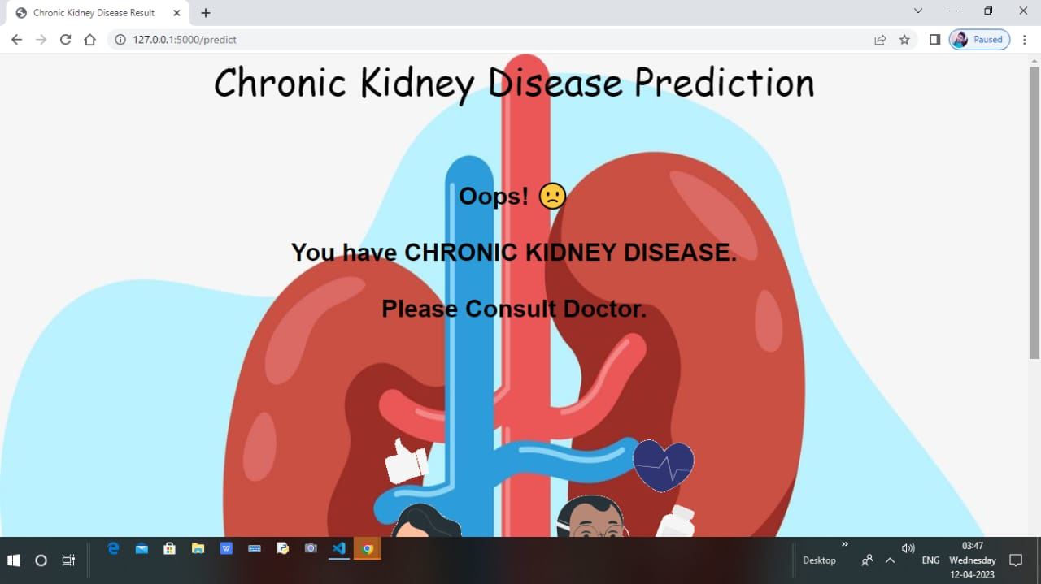

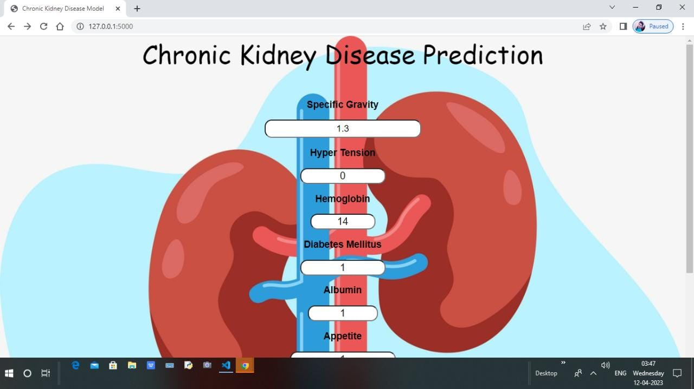
SAMPLECODING